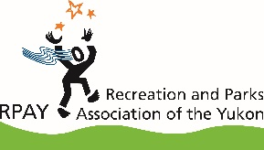
SAMPLE Registration Form

 |  |  | Date: |  |  |  |  | Program:
Name: |  |  |  |  |  |  |  |  |  |  | Phone:
Community:
Email address:
Please indicate… |  |  |  |  | Gender: |  | Female |  |  |  |  |  | Male
Age range: | - up to 12 |  |  |  | - 13 - 19 | - 20 – 35 |  |  |  | - 35 – 54 |  |  |  |  | - 55 + better
 | Do you have children under the age of 18 living at home? |  |  |  |  |  |  |  |  |  |  |  |  |  | - Yes | - No
Please indicate if applicable… |  |  |  |  | - First Nation ancestry |  |  |  |  |  |  | - Newcomer to Canada
Have you participated in RPAY’s programs before? |  |  |  |  |  |  |  |  | - yes |  |  |  |  | - no
How did you find out about this program?

Use this space for other information you may want to collect. For example:
- Are there any medical conditions such as allergies?
- What is the contact information for a parent or guardian?
- Who is the emergency contact?

For more sample forms, go to the Leisure Information Network and search “forms”.

http://lin.ca/

